**Structuring Rest Api**

1. **Initialize a New Node.js Project**

npm init -y

1. **Install Express**

npm install express

1. **Create a Basic Server**

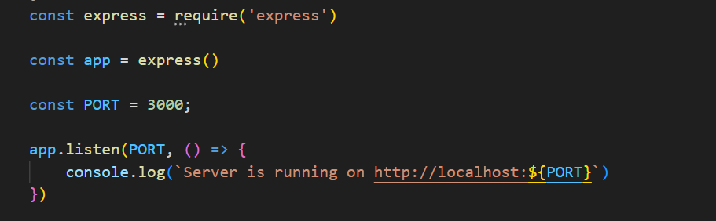

1. **Add a GET Endpoint**

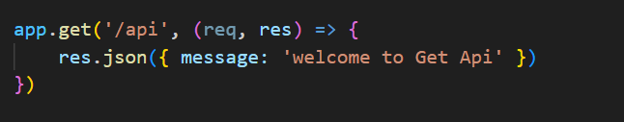

1. **Run the Server**

node server.js

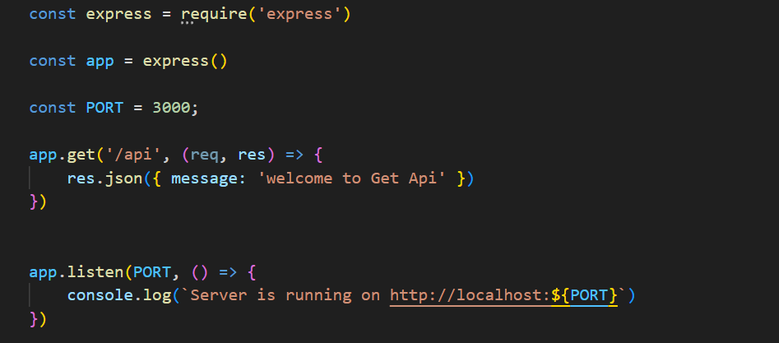

**Outputs**

